**DATA ANALYTICS LAB**

**EXERCISE 1**

S Shyam Sundaram

19BCE1560

**Q1**

Read the given table. Print the number of rows and columns. Order the table based on section.

**Code**

data<-read.csv(file='Score.csv')

stud<-data

stud<-stud[order(stud$Section, decreasing=FALSE),]

stud

dim(stud)

**Output**

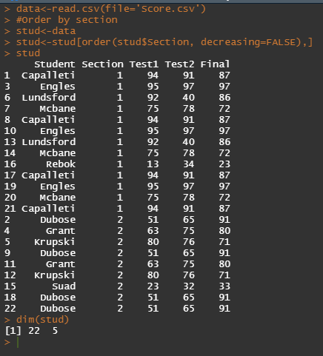

**Q2**

Remove all duplicates and display the rows and columns.

**Code**

studu<-unique(stud)

studu

dim(studu)

**Output**

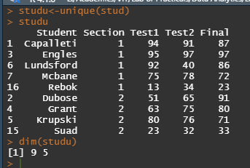

**Q3**

Transform the student scores table given below and perform the following transformations. The students have been conducted two tests and a final exam. The weightage for Test 1&2 are 25 each. The weightage for the final exam is 50. Add columns for the updated test1, test2 and final exam by normalizing them according to their respective weights.

**Code**

studu <- transform(studu,upTest1 = (Test1/100)*25)

studu <- transform(studu,upTest2 = (Test2/100)*25)

studu <- transform(studu,upFinal = (Final/100)*50)

studu

**Output**

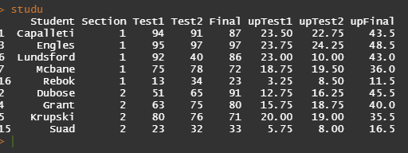

**Q4**

Sum the normalized columns to obtain the TotalMarks out of 100. Calculate the mean of the total marks.

**Code**

studu <- transform(studu,TotalMarks = upTest1+upTest2+upFinal)

studu

me<-mean(studu$TotalMarks)

me

**Output**

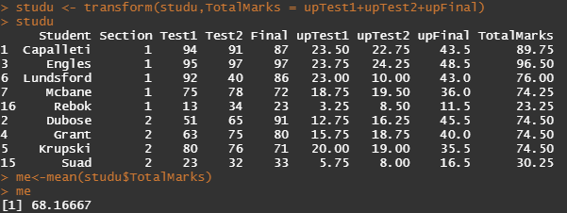

**Q5**

Add a new column Grade which splits the students into three categories and label them as Above Average (AA), Below Average (BA), Fail(FAIL). Note that students below 50 are considered FAIL.

**Code**

studu$Grades <- cut(studu$TotalMarks,breaks=c(-Inf,50,me,Inf), labels=c("FAIL","BA","AA"))

studu

**Output**

